|  |  |
| --- | --- |
| Name | Kashaf ishfaq |
| Ag # | 2018-ag-1828 |
| Section | B |
| Github ID | [Kashafishfaq45@gmail.com](mailto:Kashafishfaq45@gmail.com) |

Assignment week 7

class Bubblesort{

public static void main( String args[]){

int array[]= {10,-3,60,78,7,0,11,100,15,1};

int a,b,t;

int size=10;

for( a=1; a<10 ; a++)

for( b=size-1; b>=a; b--)

{

if(array[b-1]>array[b]){

t=array[b-1];

array[b-1]=array[b];

array[b]=t;

}

}

System.out.println(" sorted array is");

for(int i=0; i<size; i++)

{

System.out.println( array[i]);

}

}

}

Assignment week 6

class Ragged{

public static void main( String args[]){

int array[][] = new int[7][];

array[0]=new int[10];

array[1]=new int[10];

array[2]=new int[10];

array[3]=new int[10];

array[4]=new int[10];

array[5]=new int[2];

array[6]=new int[2];

for(int i=0;i<5;i++)

for(int j=0;j<10;j++)

{

array[i][j]= i+j+10;

}

for(int i=5;i<7;i++)

for(int j=0;j<2;j++){

array[i][j]= i+j+10;

}

System.out.println("riders per week");

for(int i=0;i<5;i++)

for(int j=0;j<10;j++)

{

array[i][j]= i+j+10;

System.out.println(array[i][j]);

System.out.println();

}

System.out.println();

System.out.println("riders on weekend");

for(int i=5;i<7;i++)

for(int j=0;j<2;j++){

array[i][j]= i+j+10;

System.out.println(array[i][j]);

System.out.println();

}

}

}

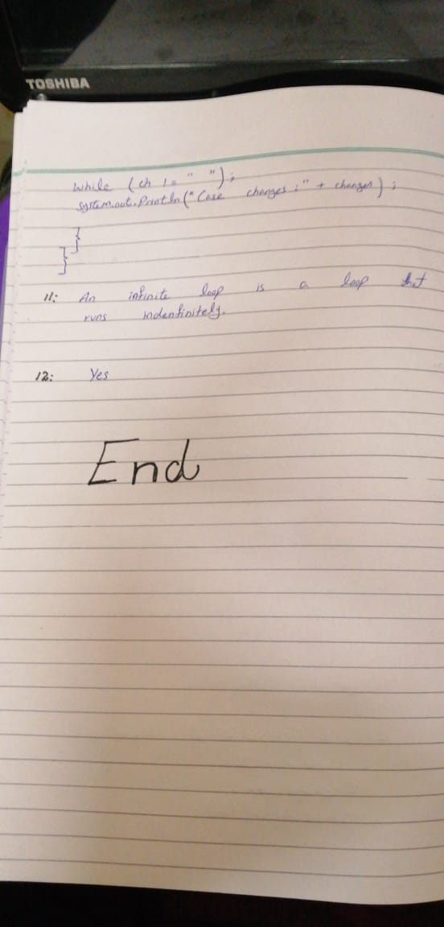

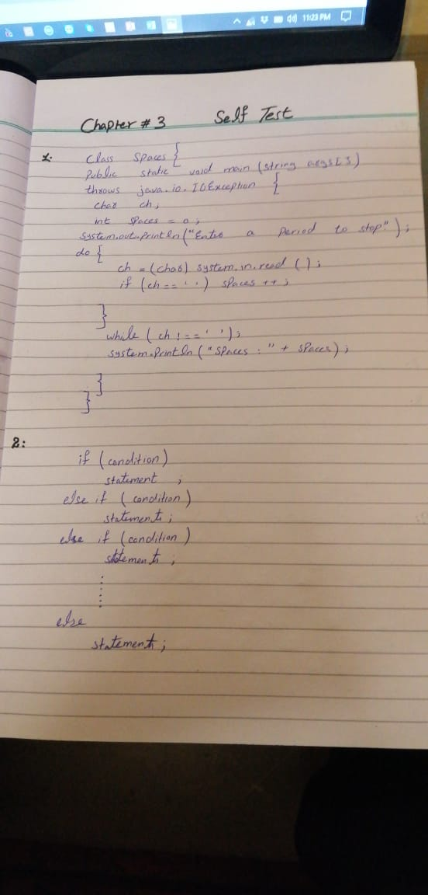

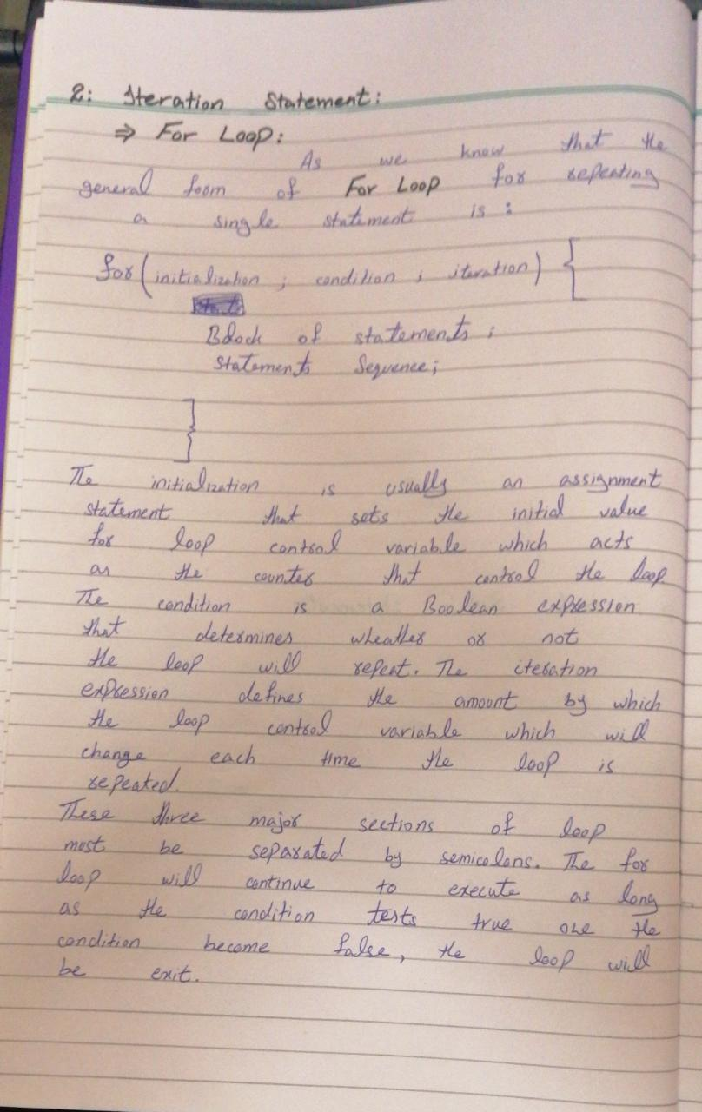

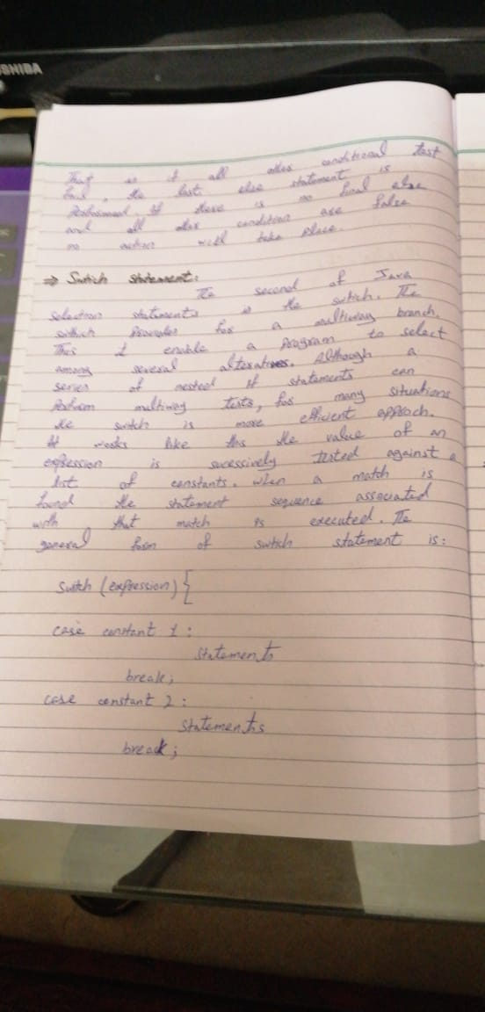



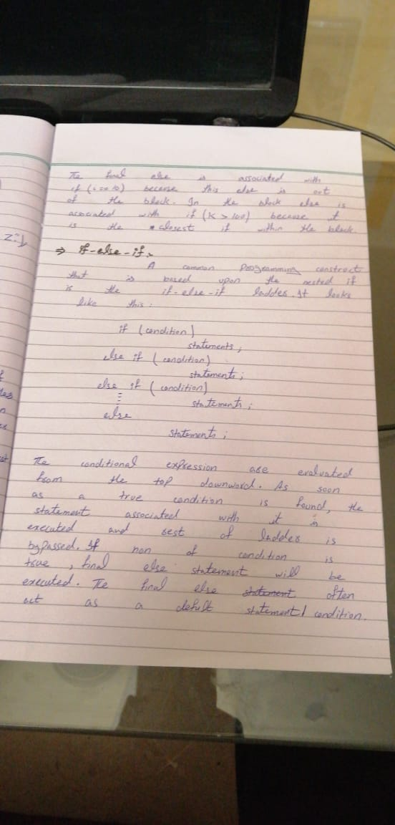 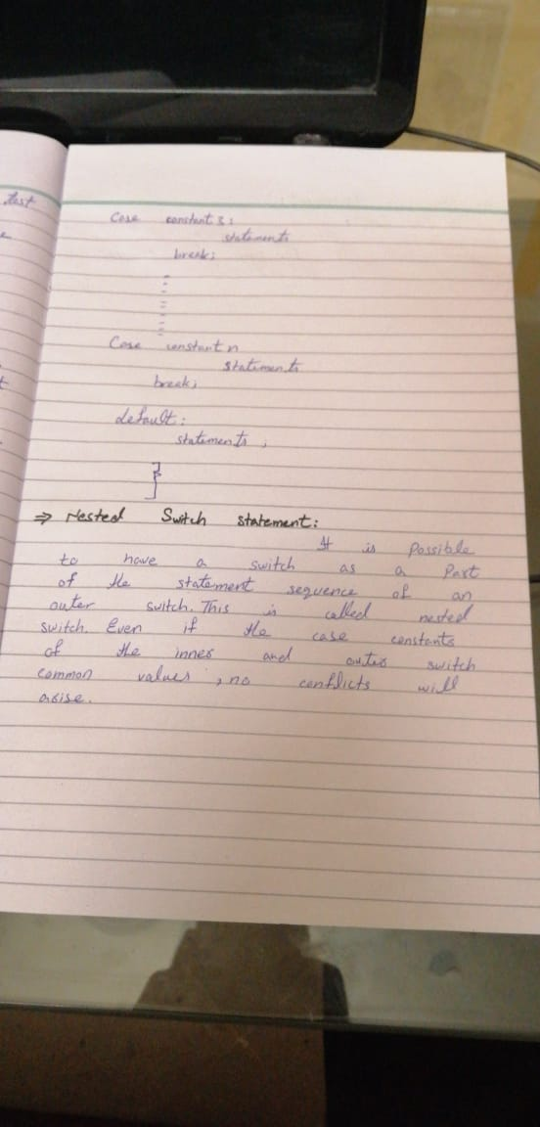

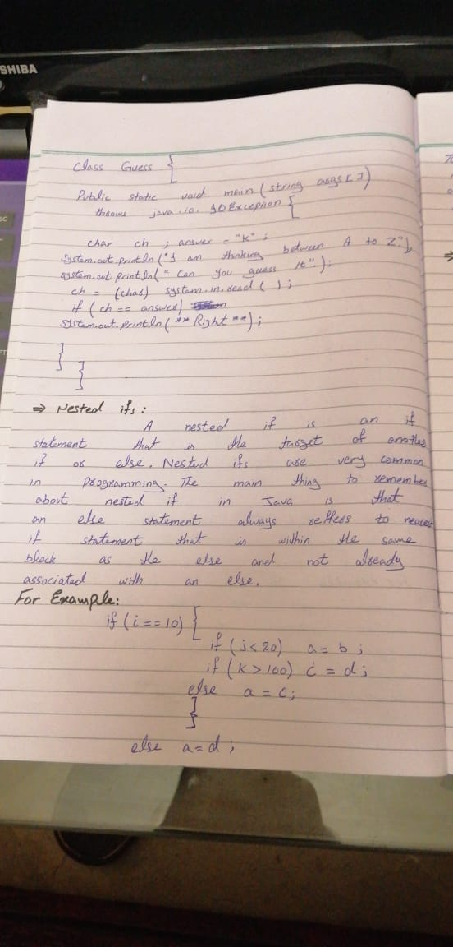

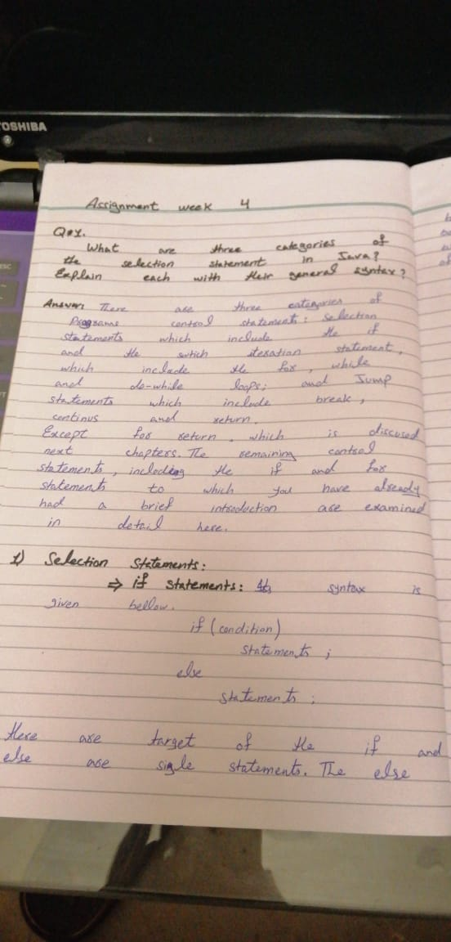

Assignment week 3

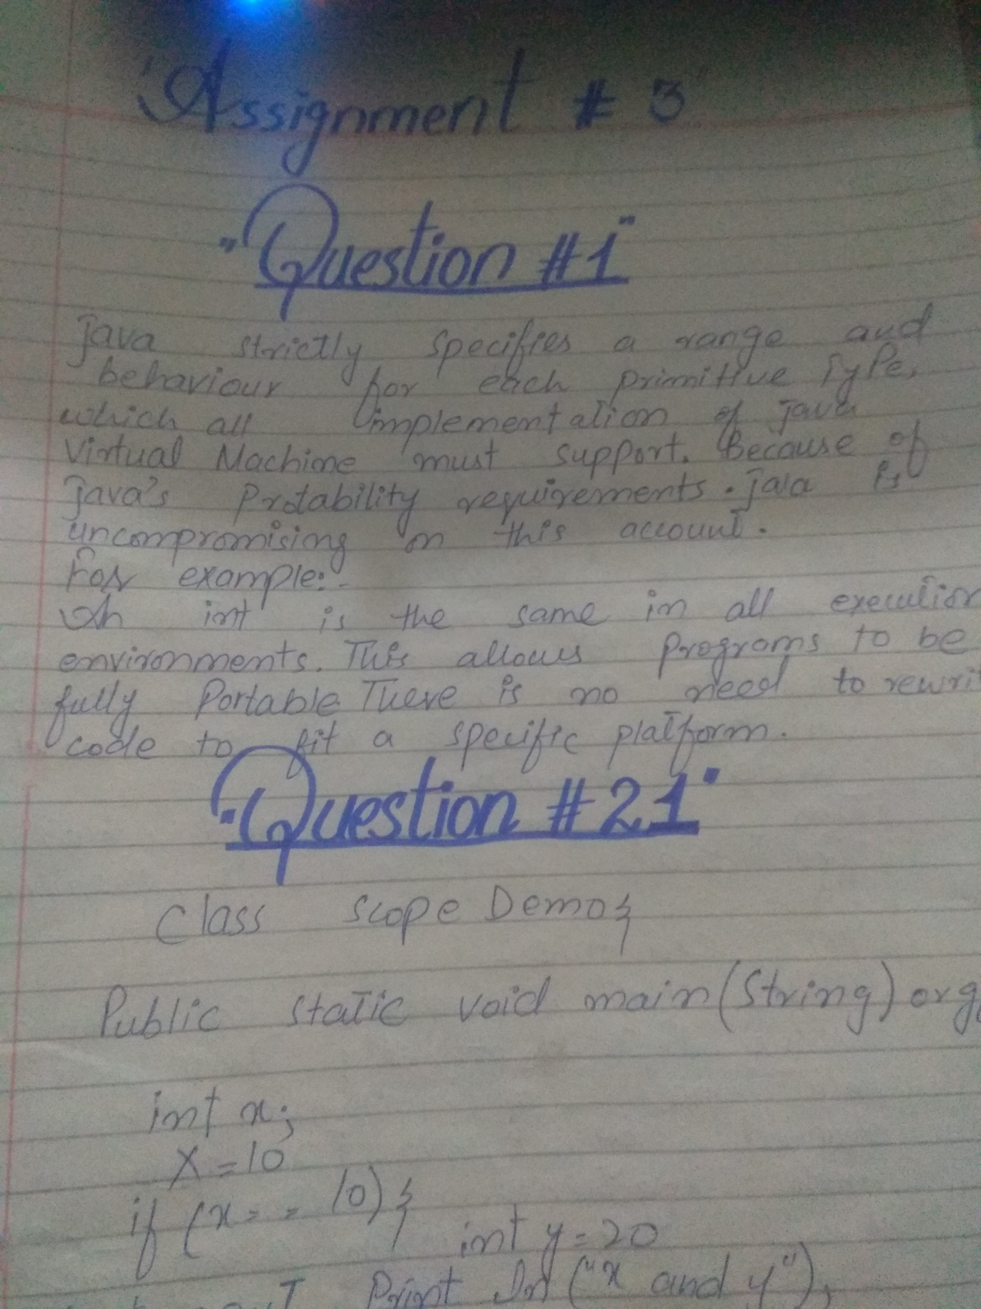

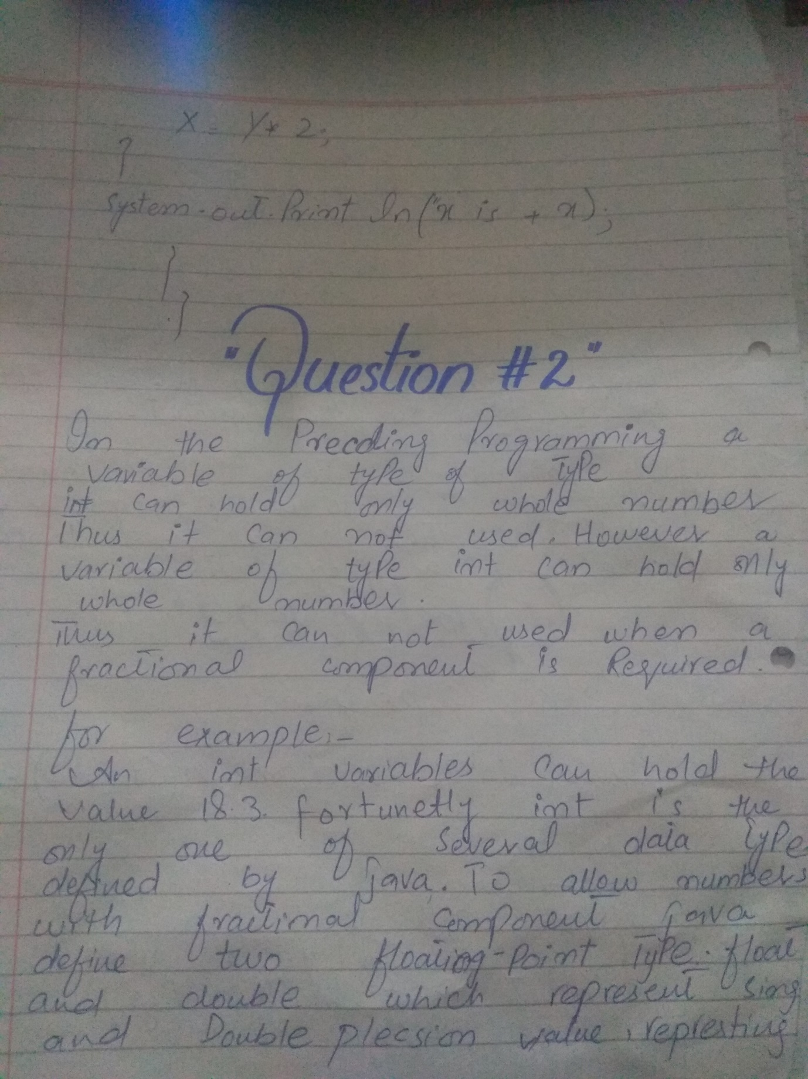

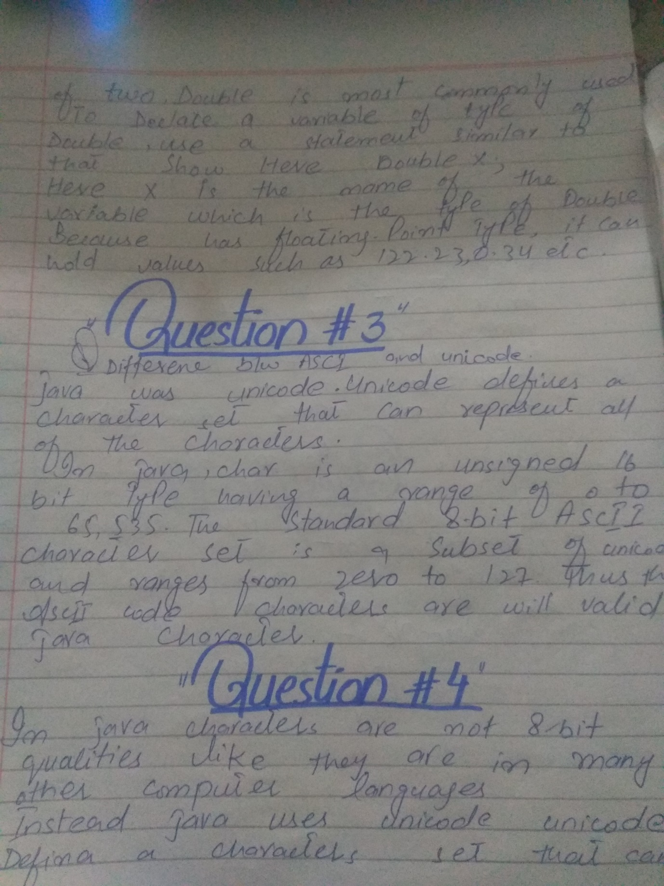

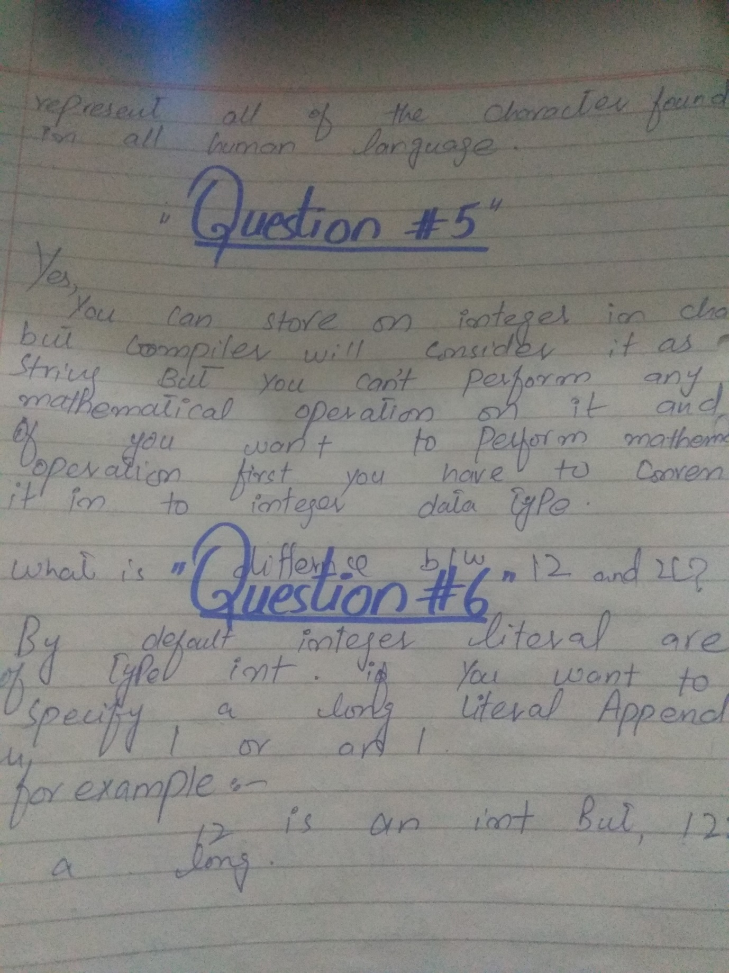

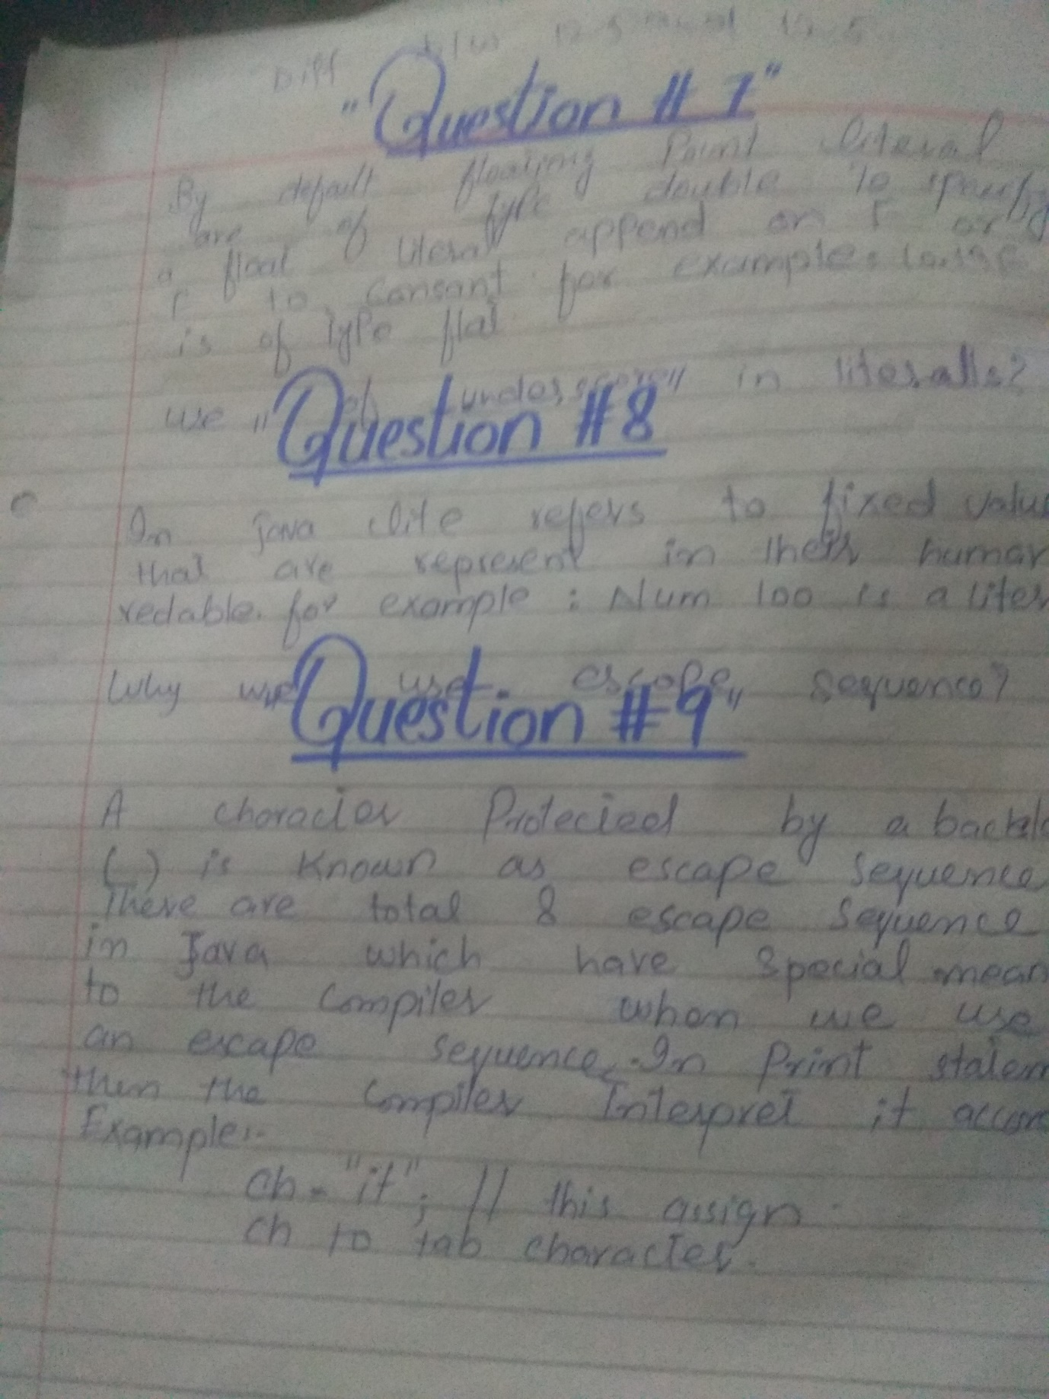

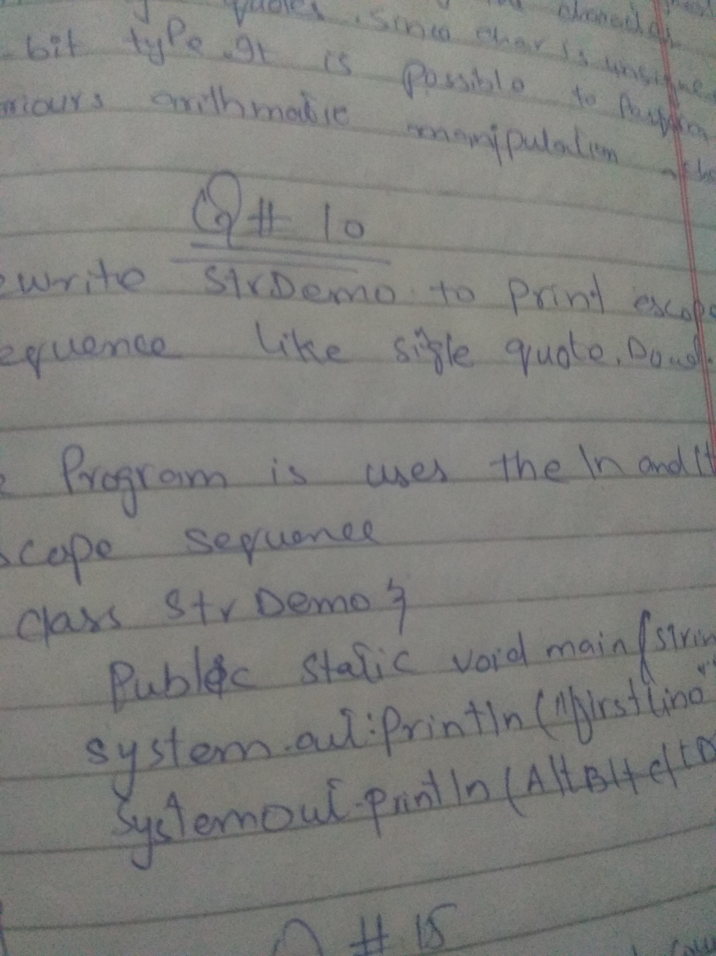

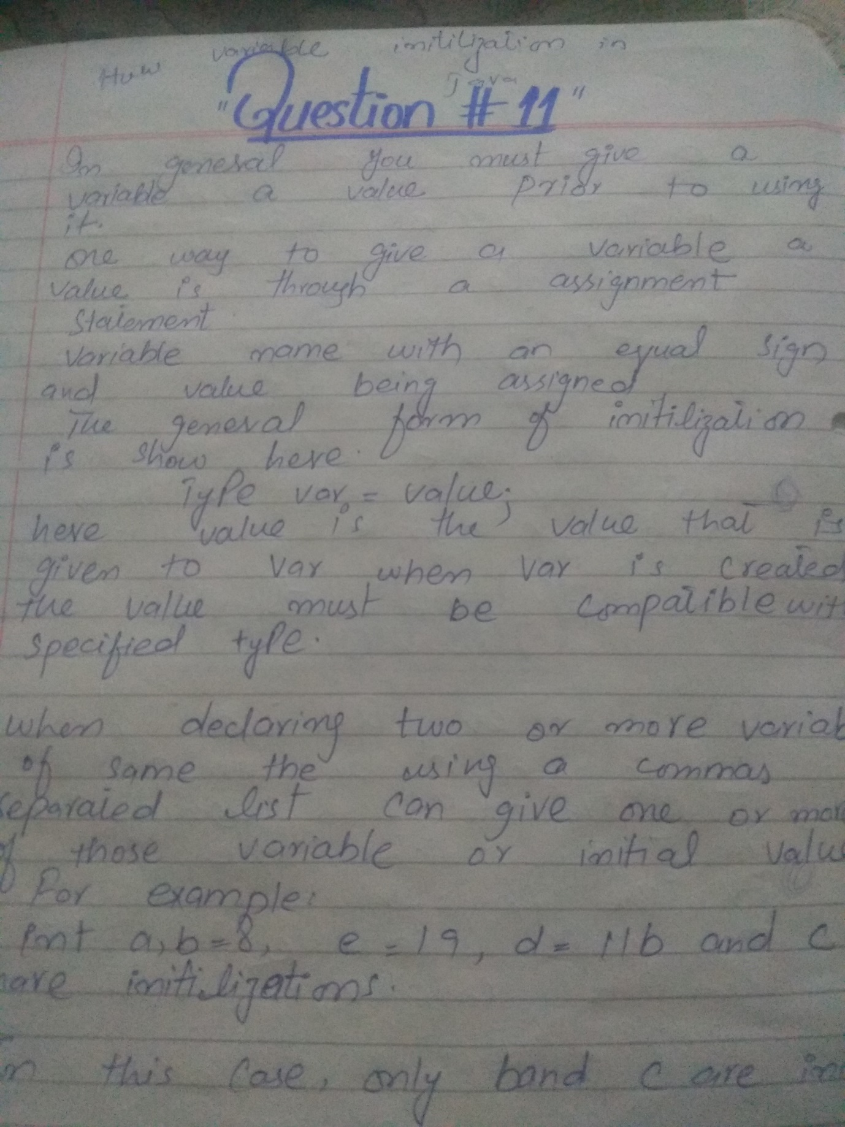

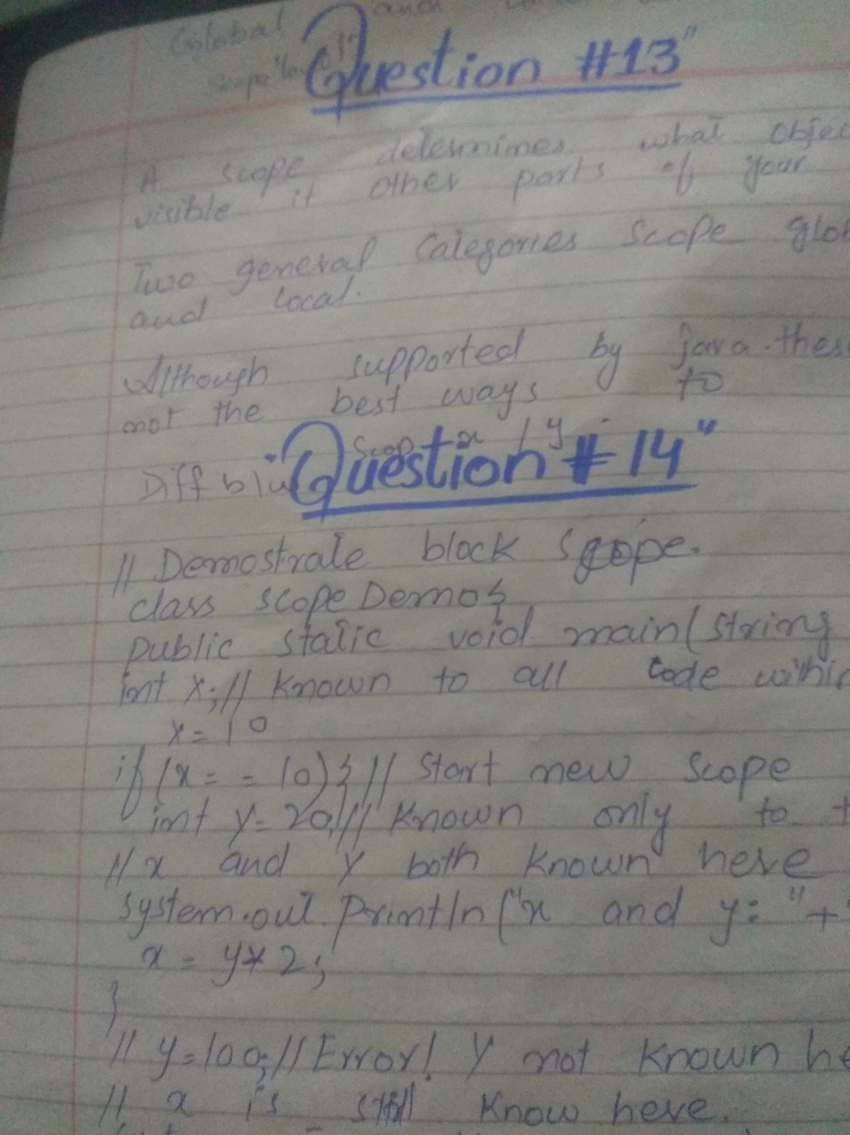

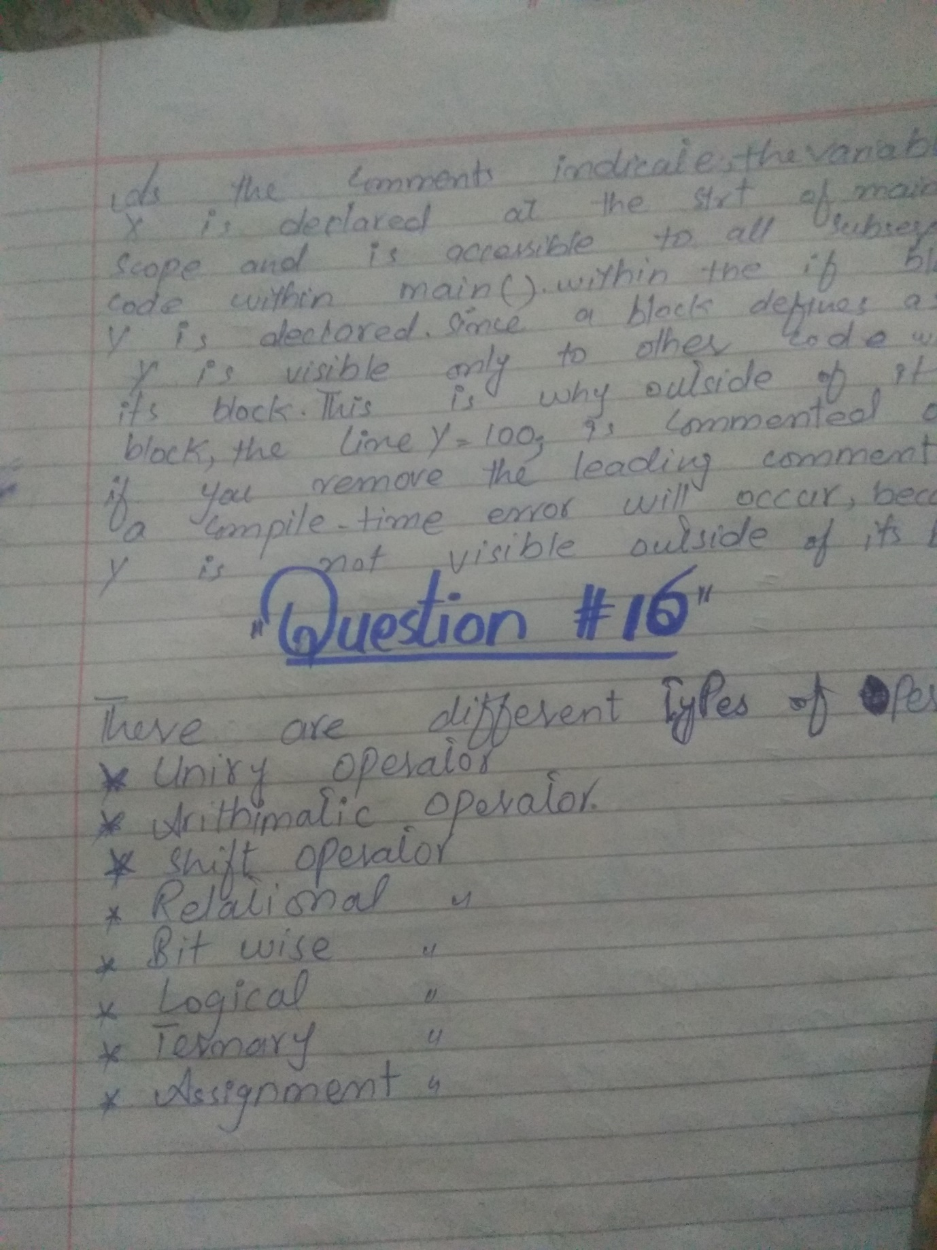

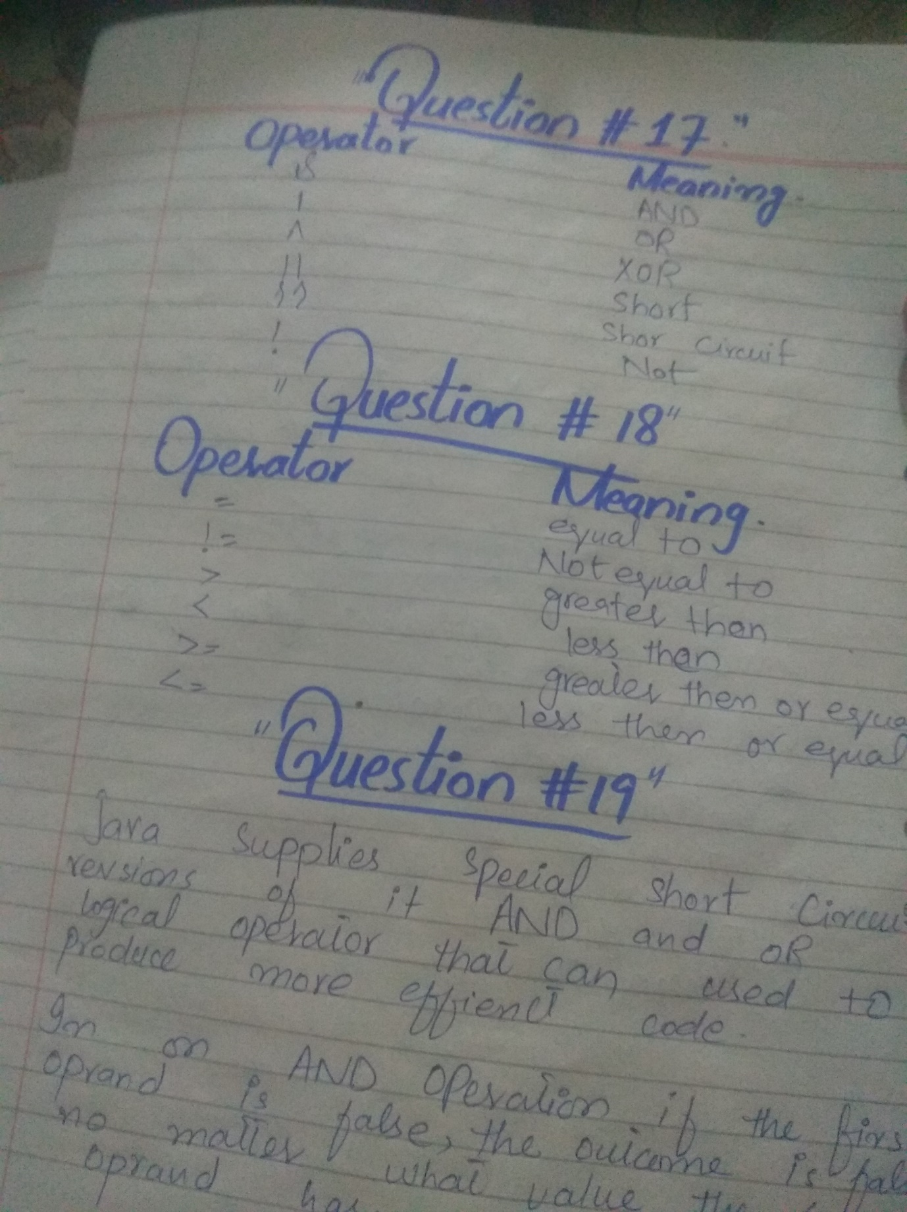

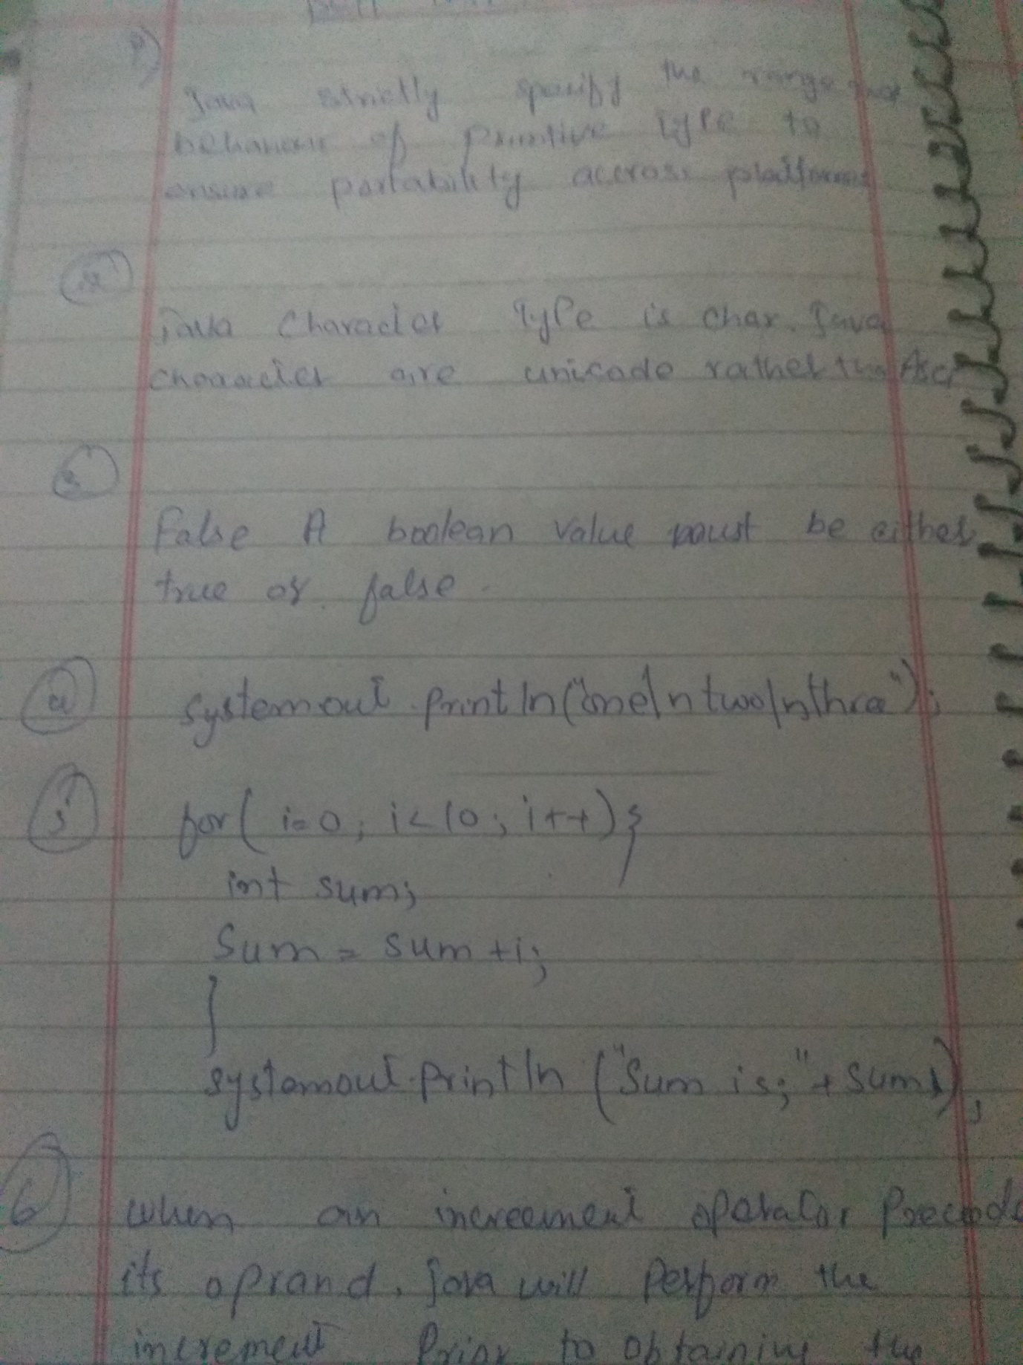

Assignment week 2

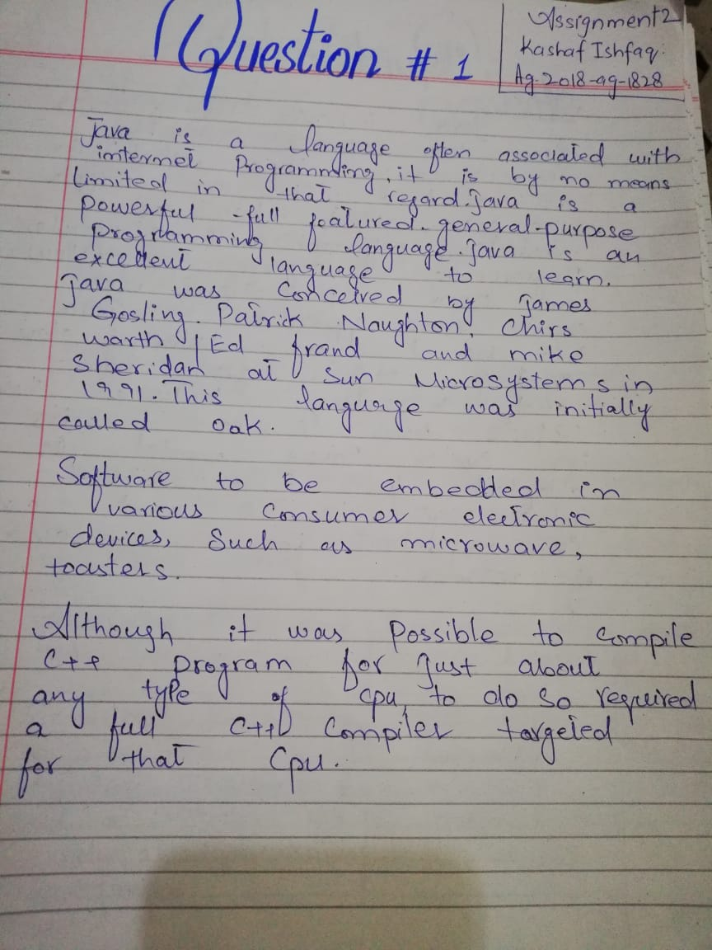

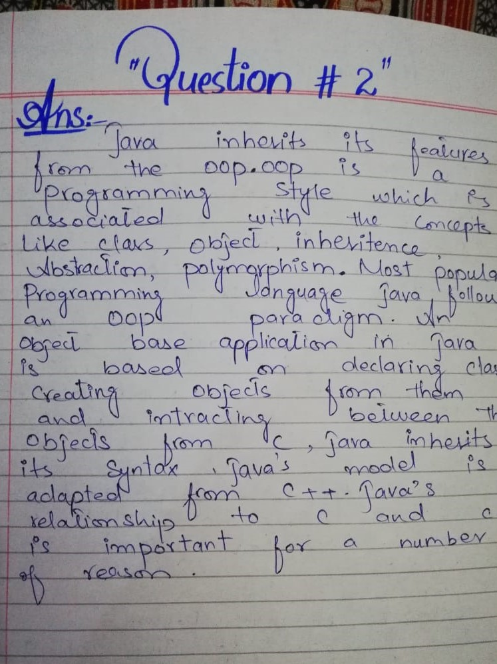

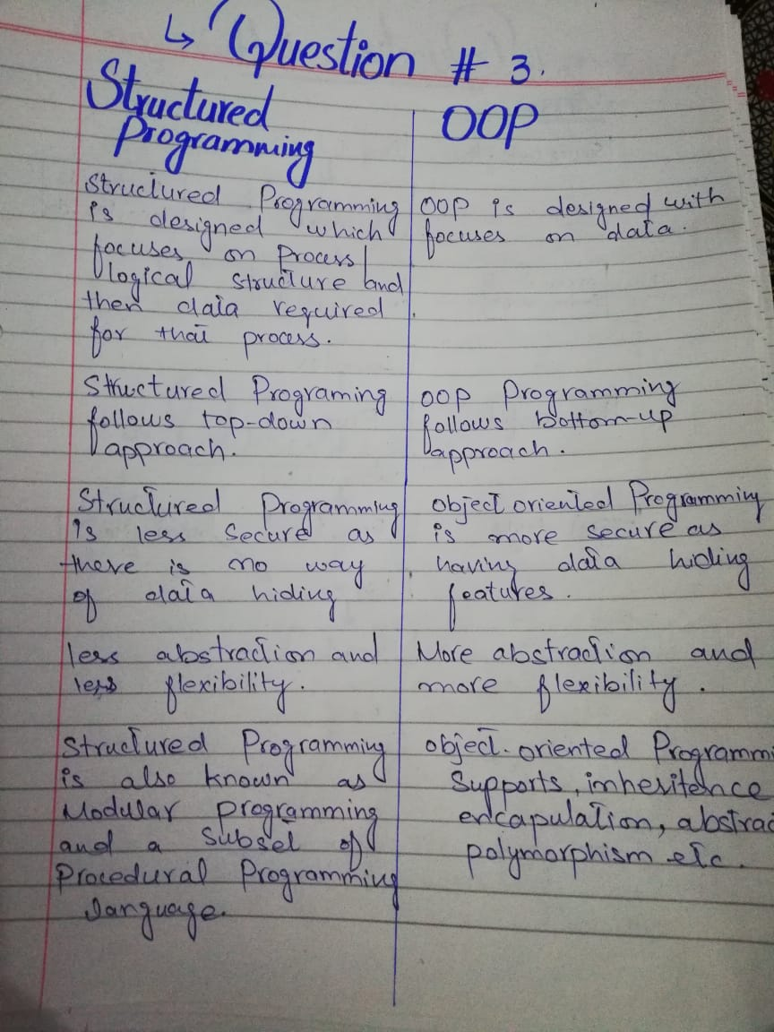

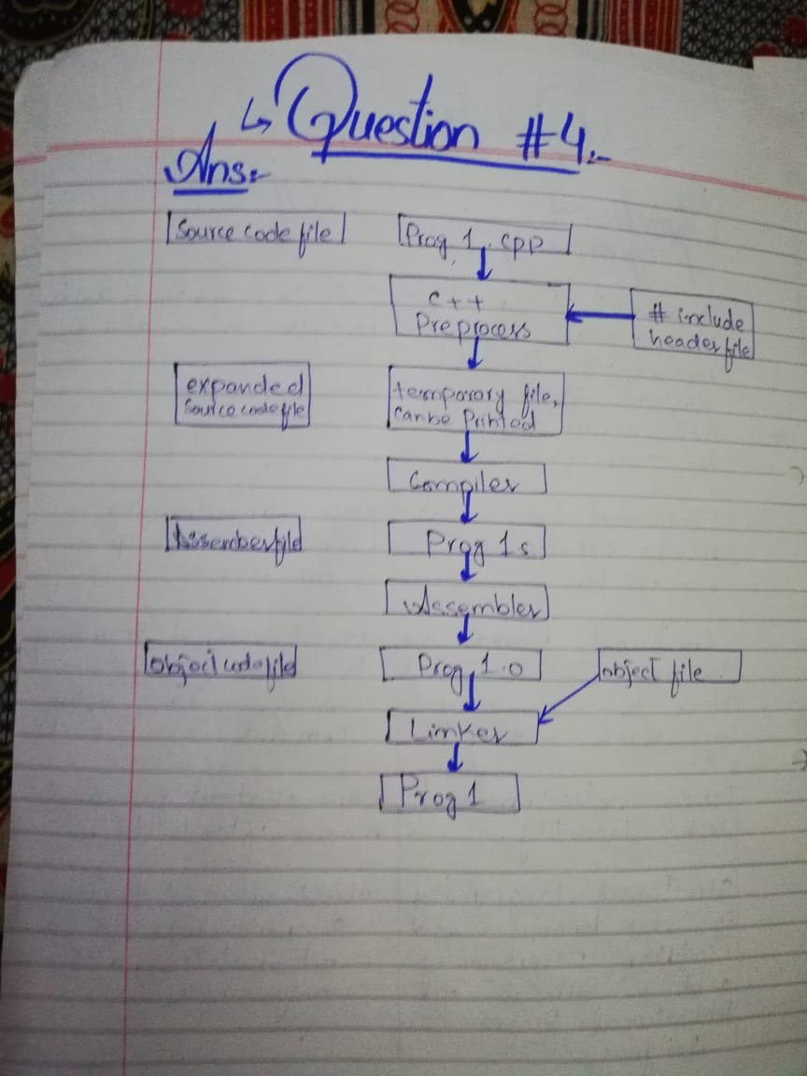

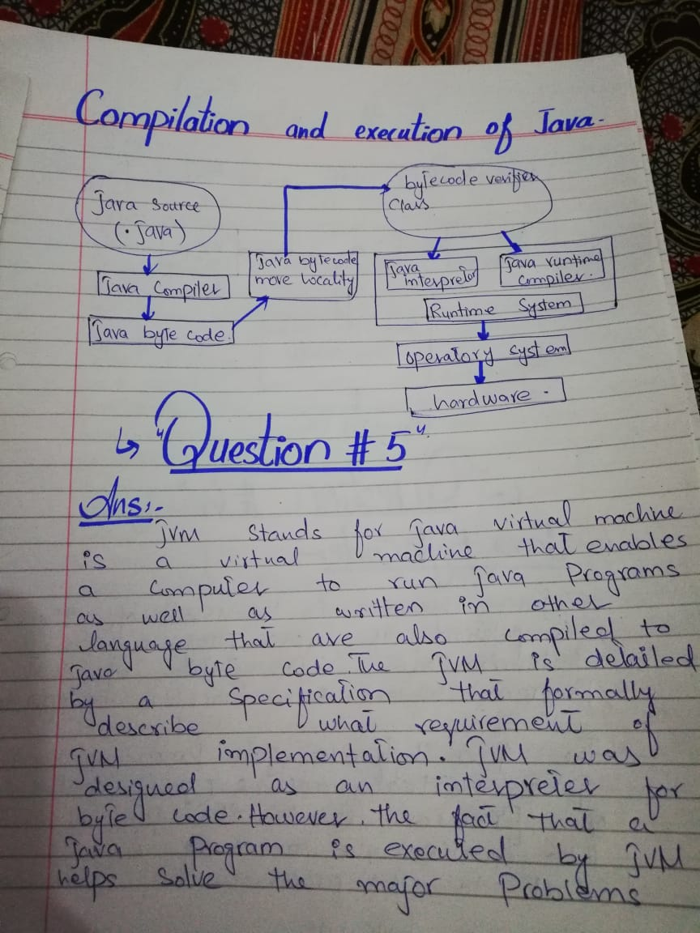

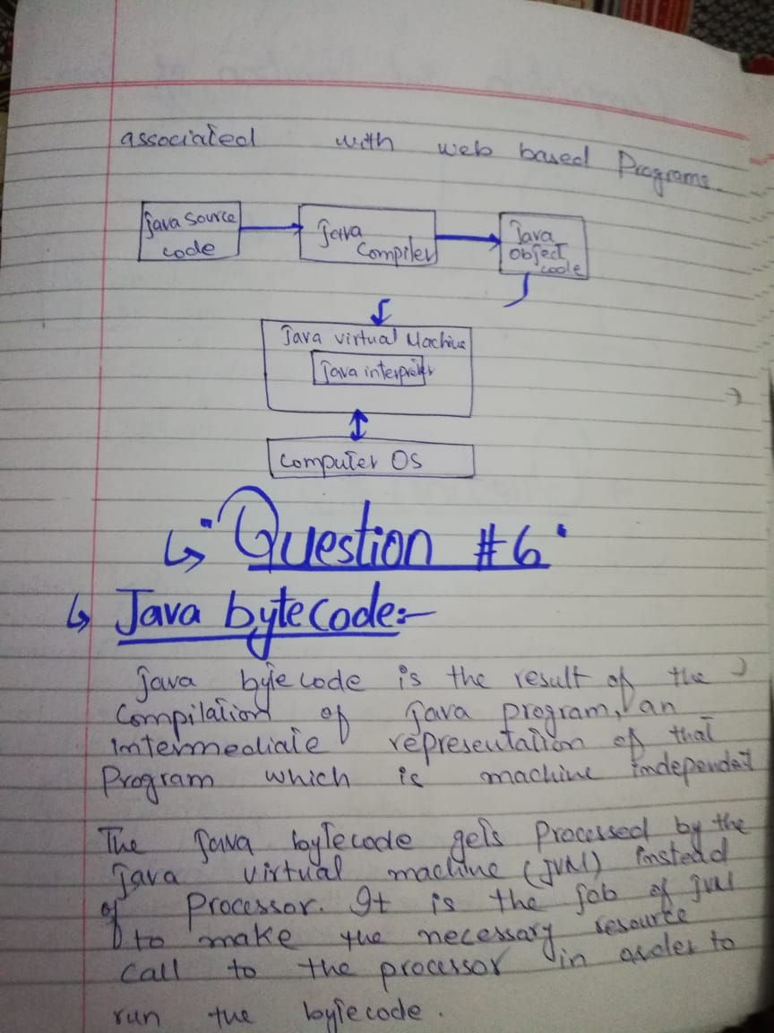

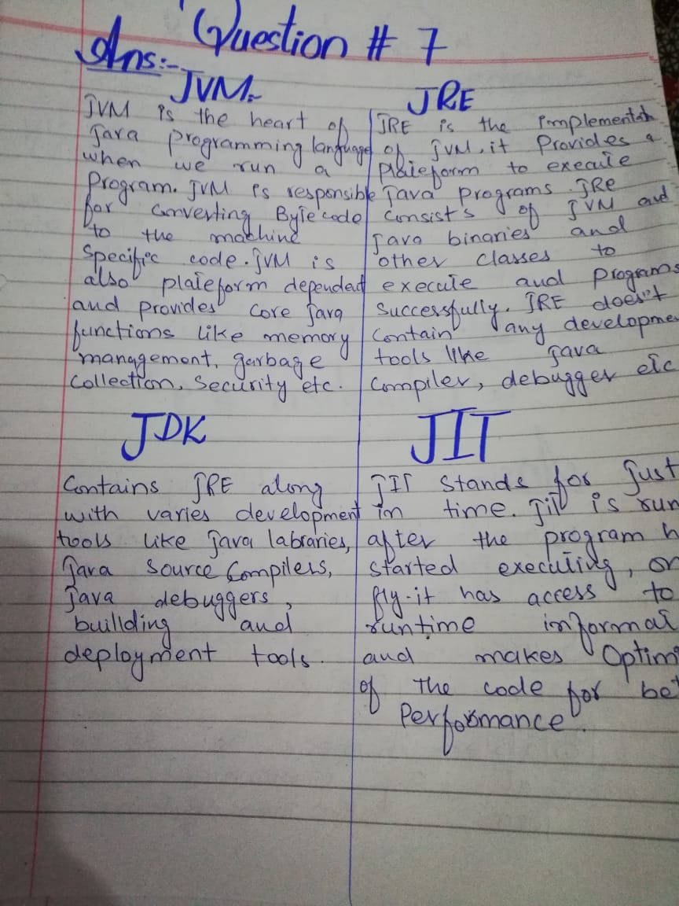

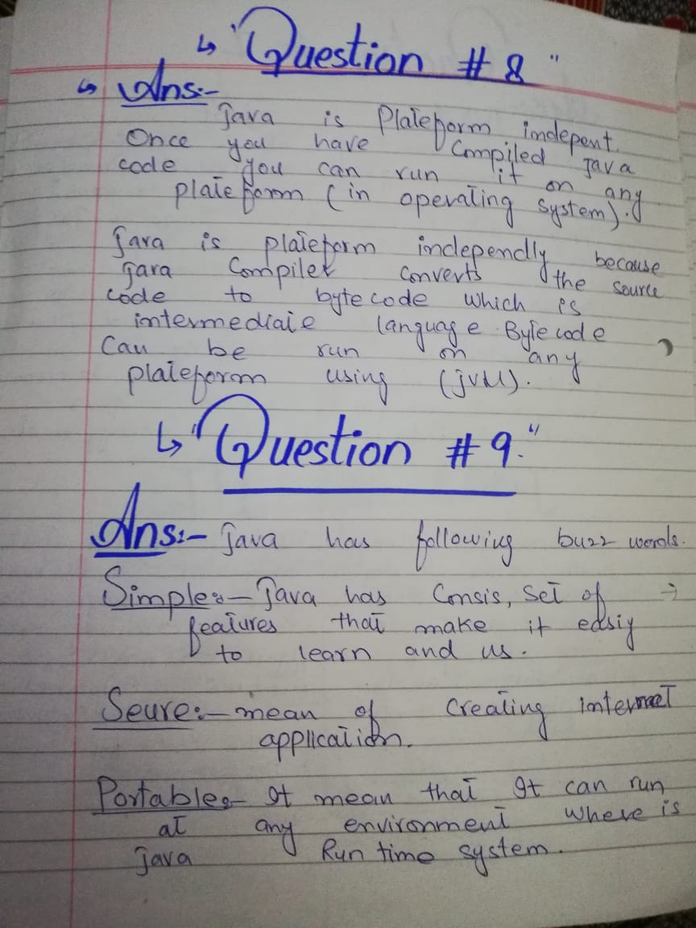

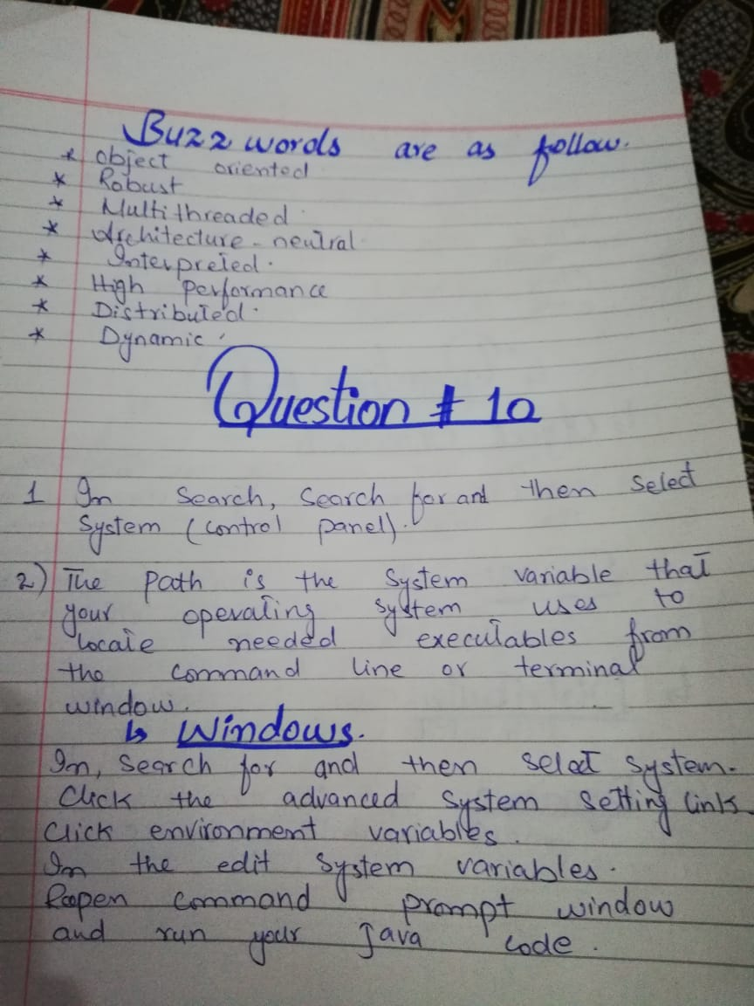

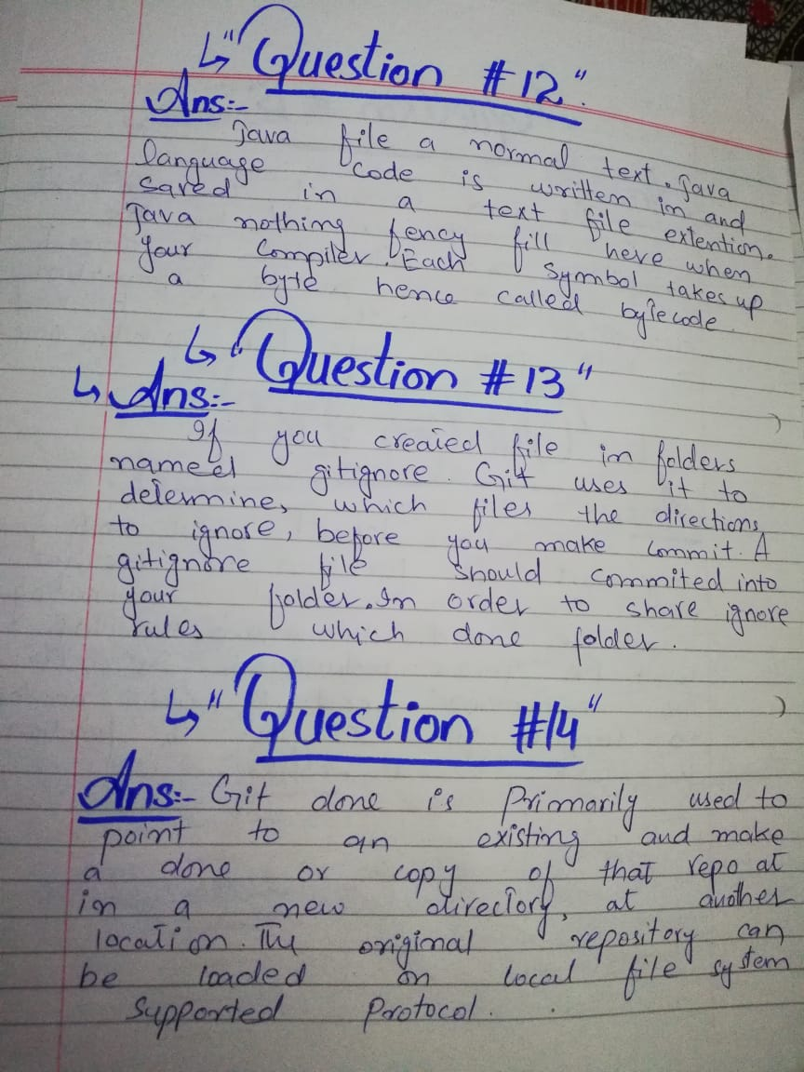

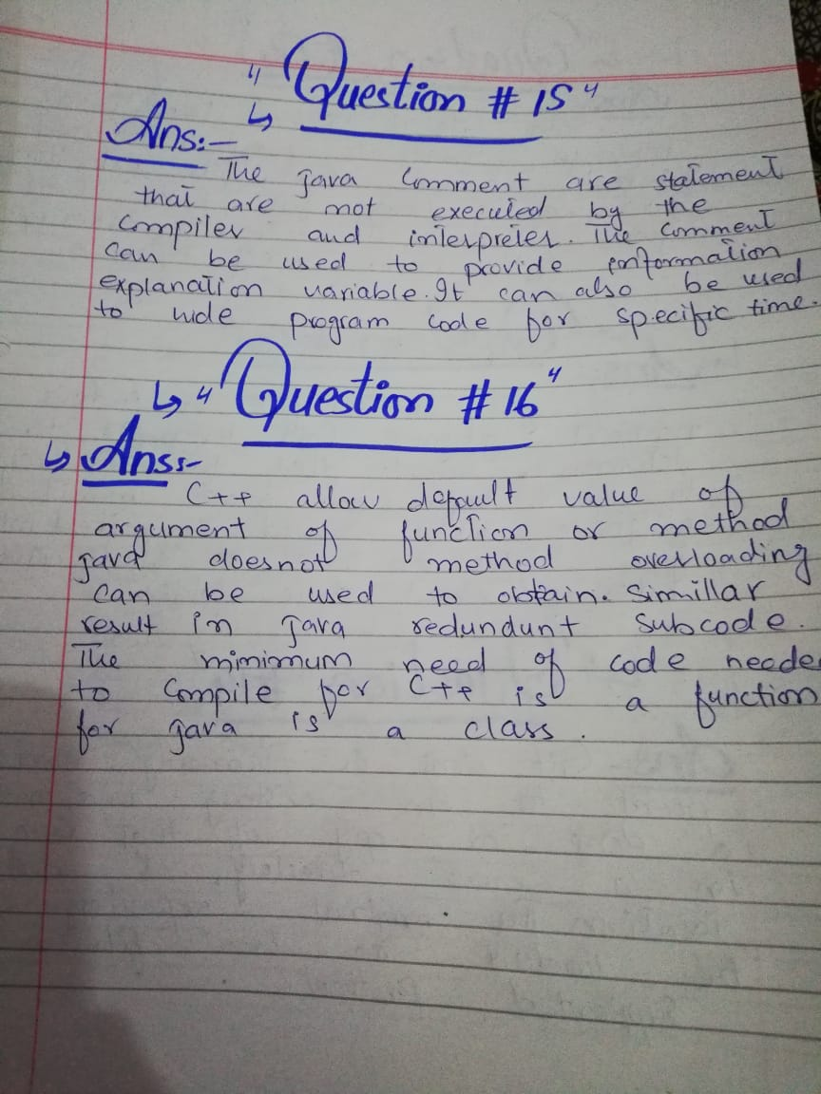

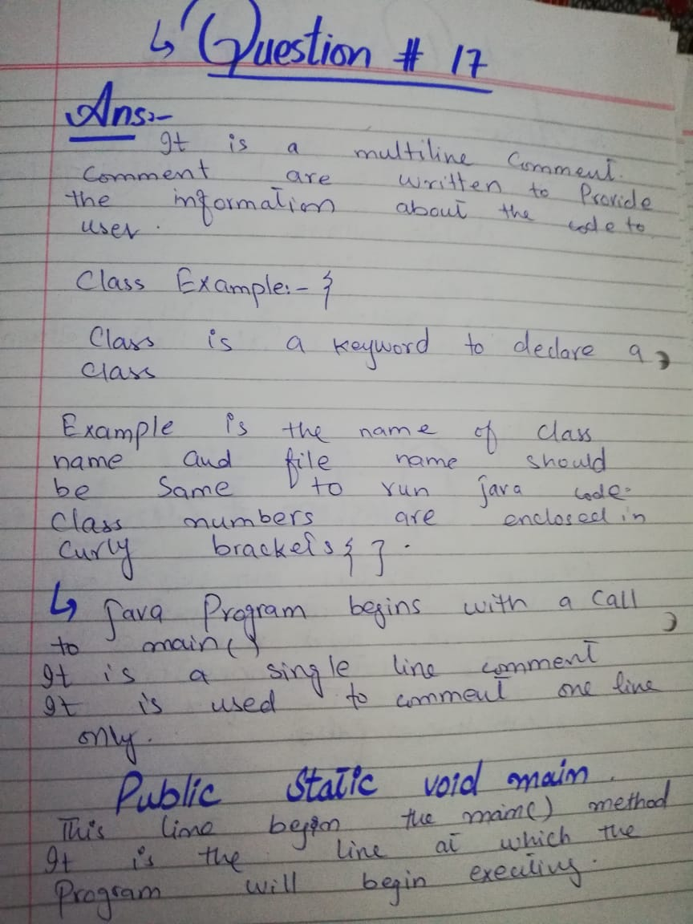

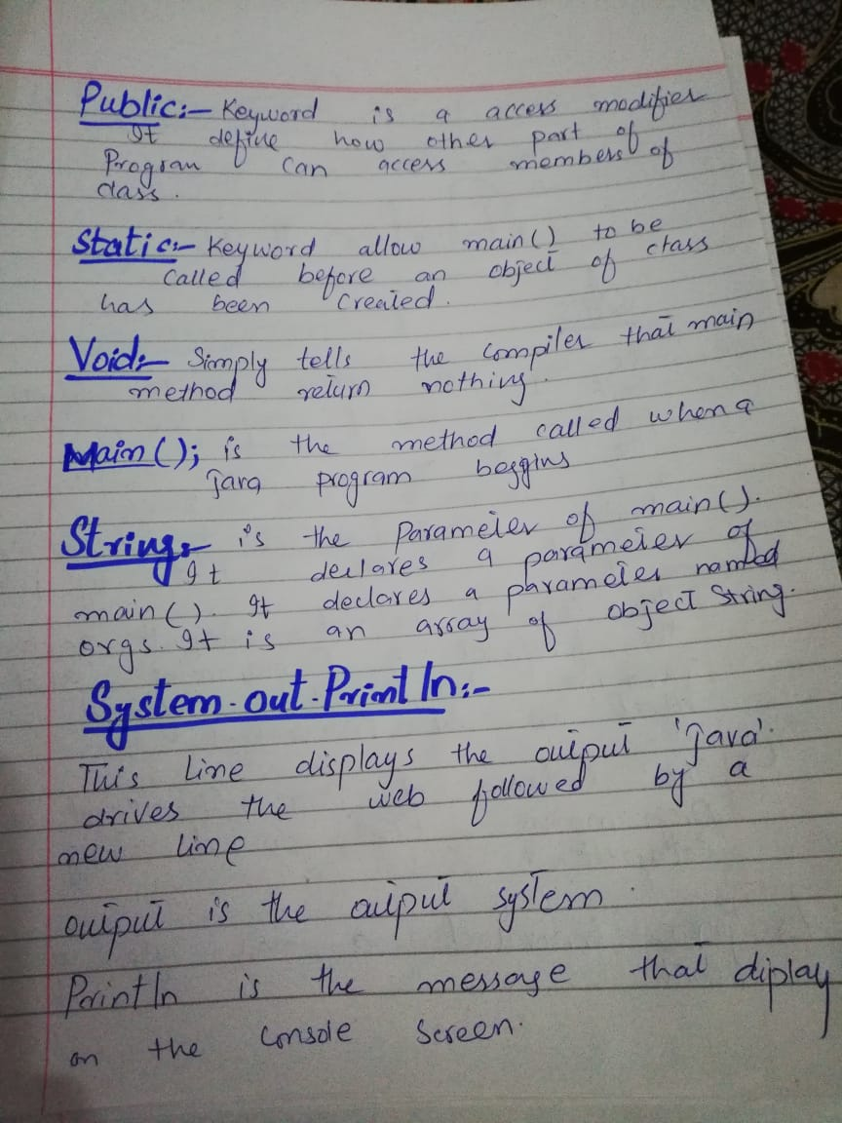

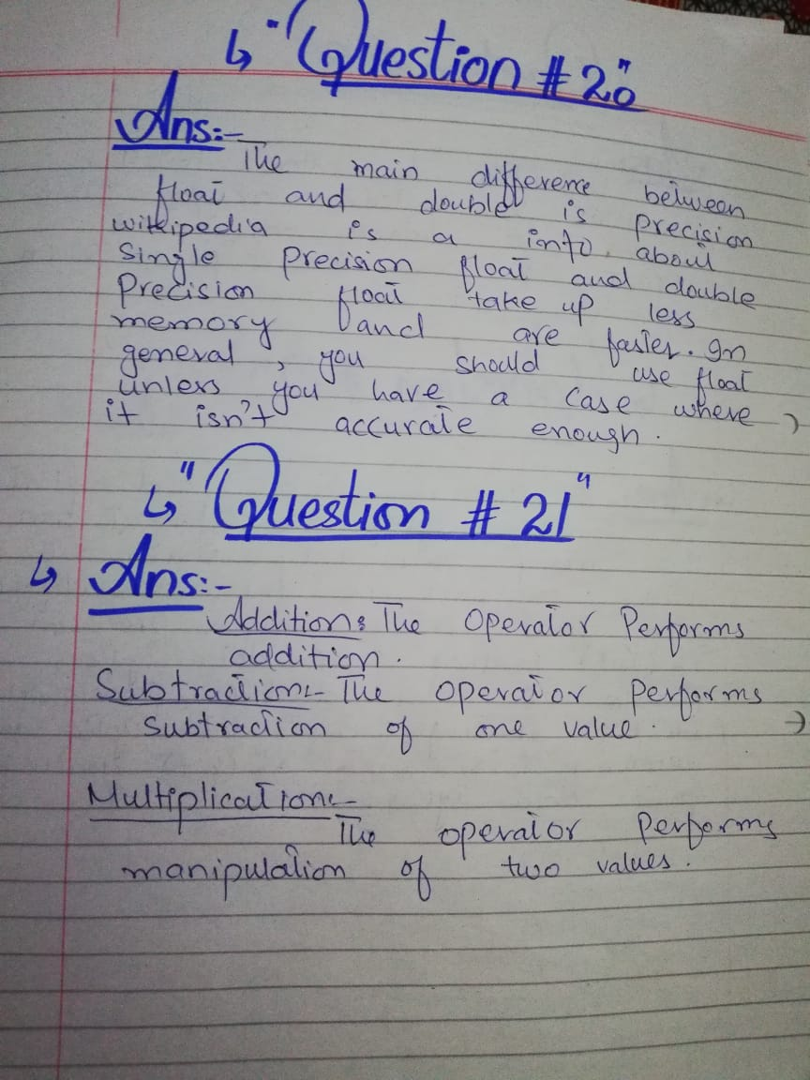

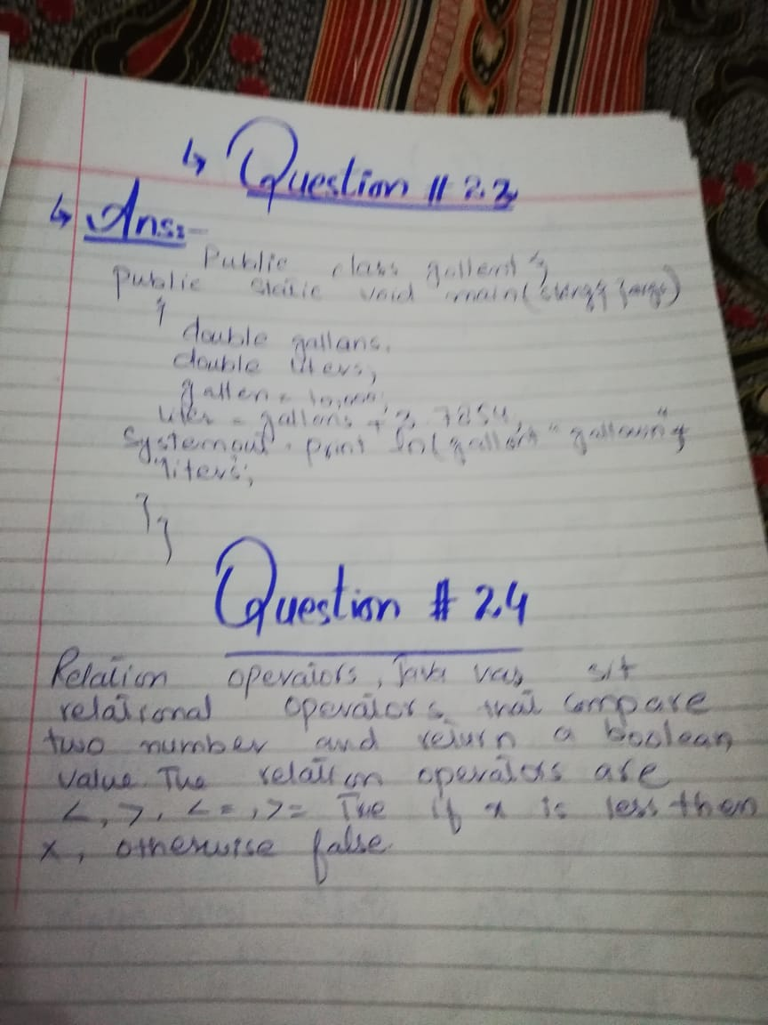

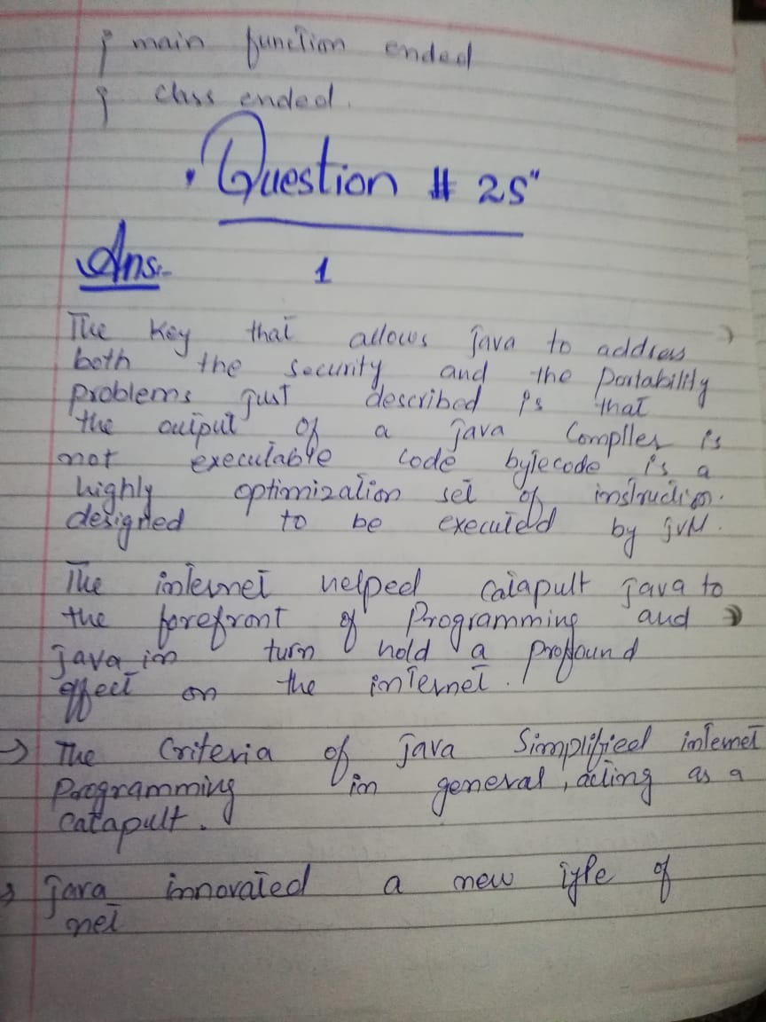

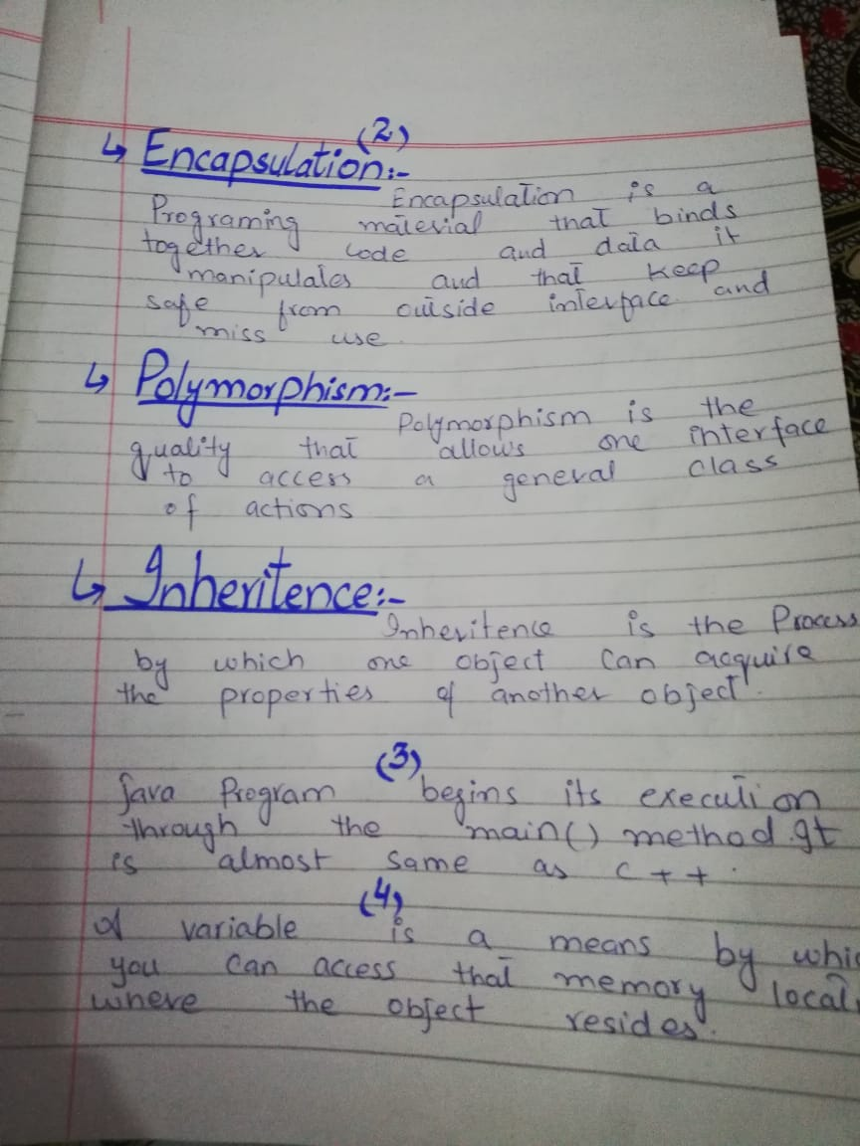

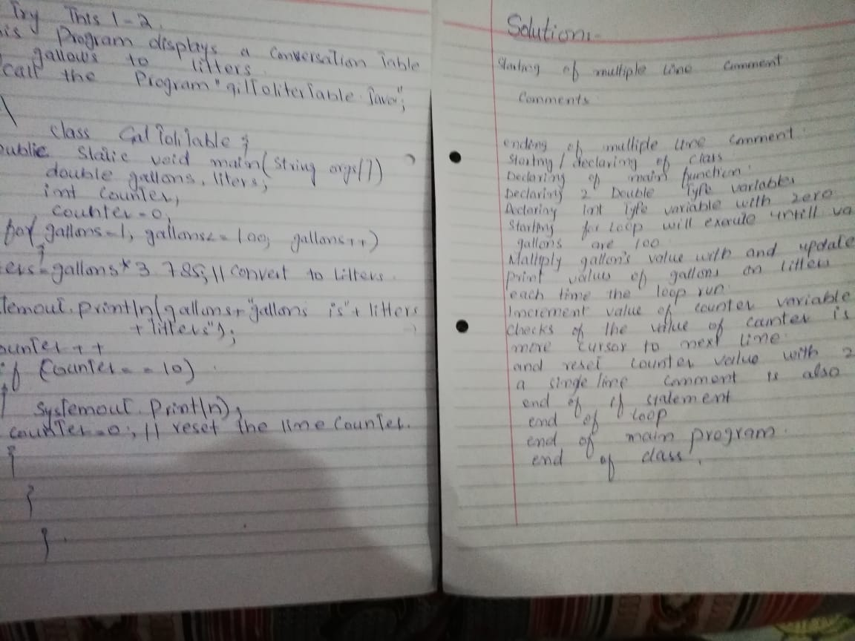

**Assignment week 1**

Q1. Place the screenshot of CMD or Gitbash showing the version of your Java complier in

the assignment file in your shared Dropbox folder

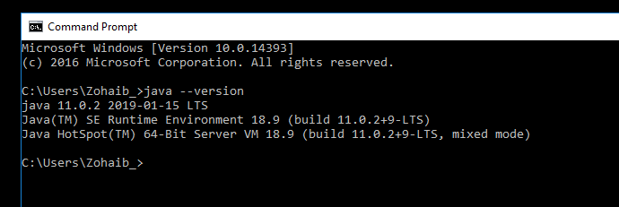

Q2. Place the screenshot of CMD or Gitbash showing the version of your git in the

assignment

file in your shared Dropbox folder.

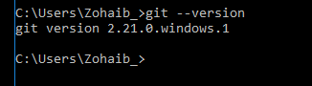

Q3. Place the screenshot of CMD or Gitbash after running

**git status**

command in the

assignment file in your shared Dropbox folder.

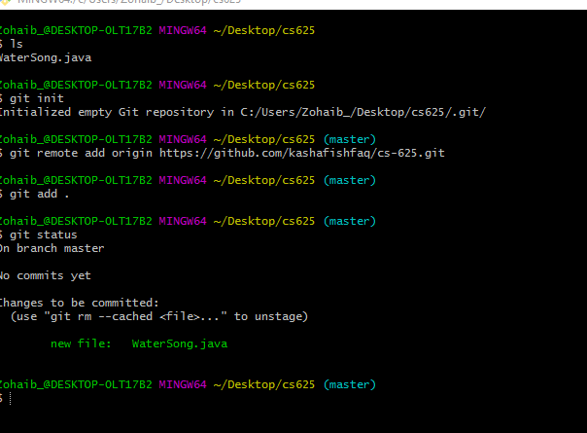

Q4. Write the following code on the note book. In front of each line of the code explain

it in

your own words. Place the pictures of it on the assignment file in your shared Dropbox

folder.

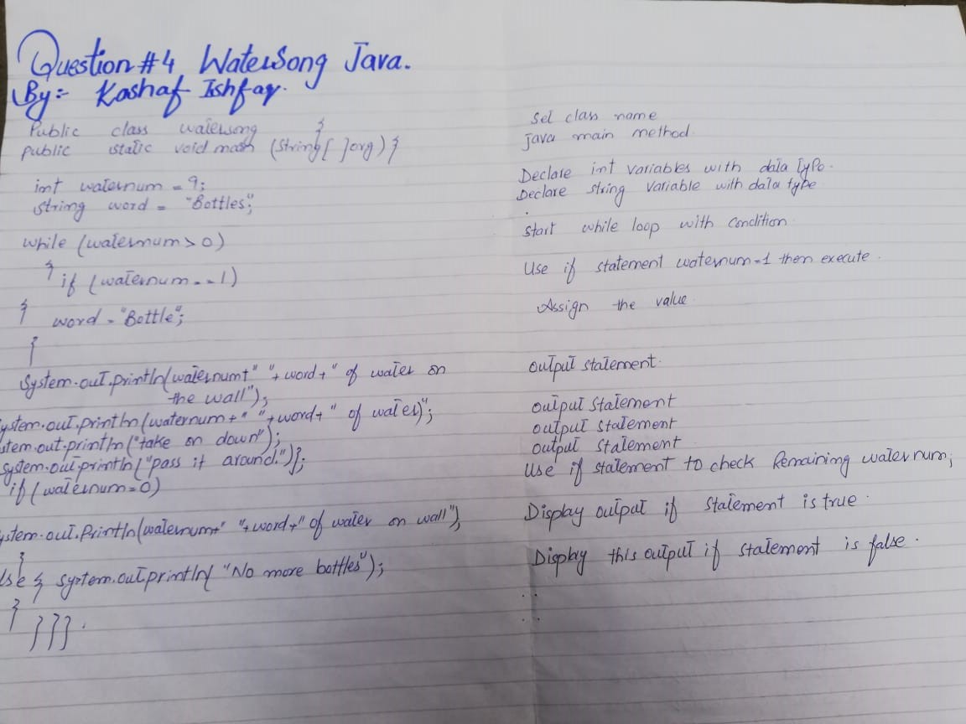

Q5. Execute the code step by step on your note book and past the pictures of it in

the

assignment file in your shared Dropbox folder.

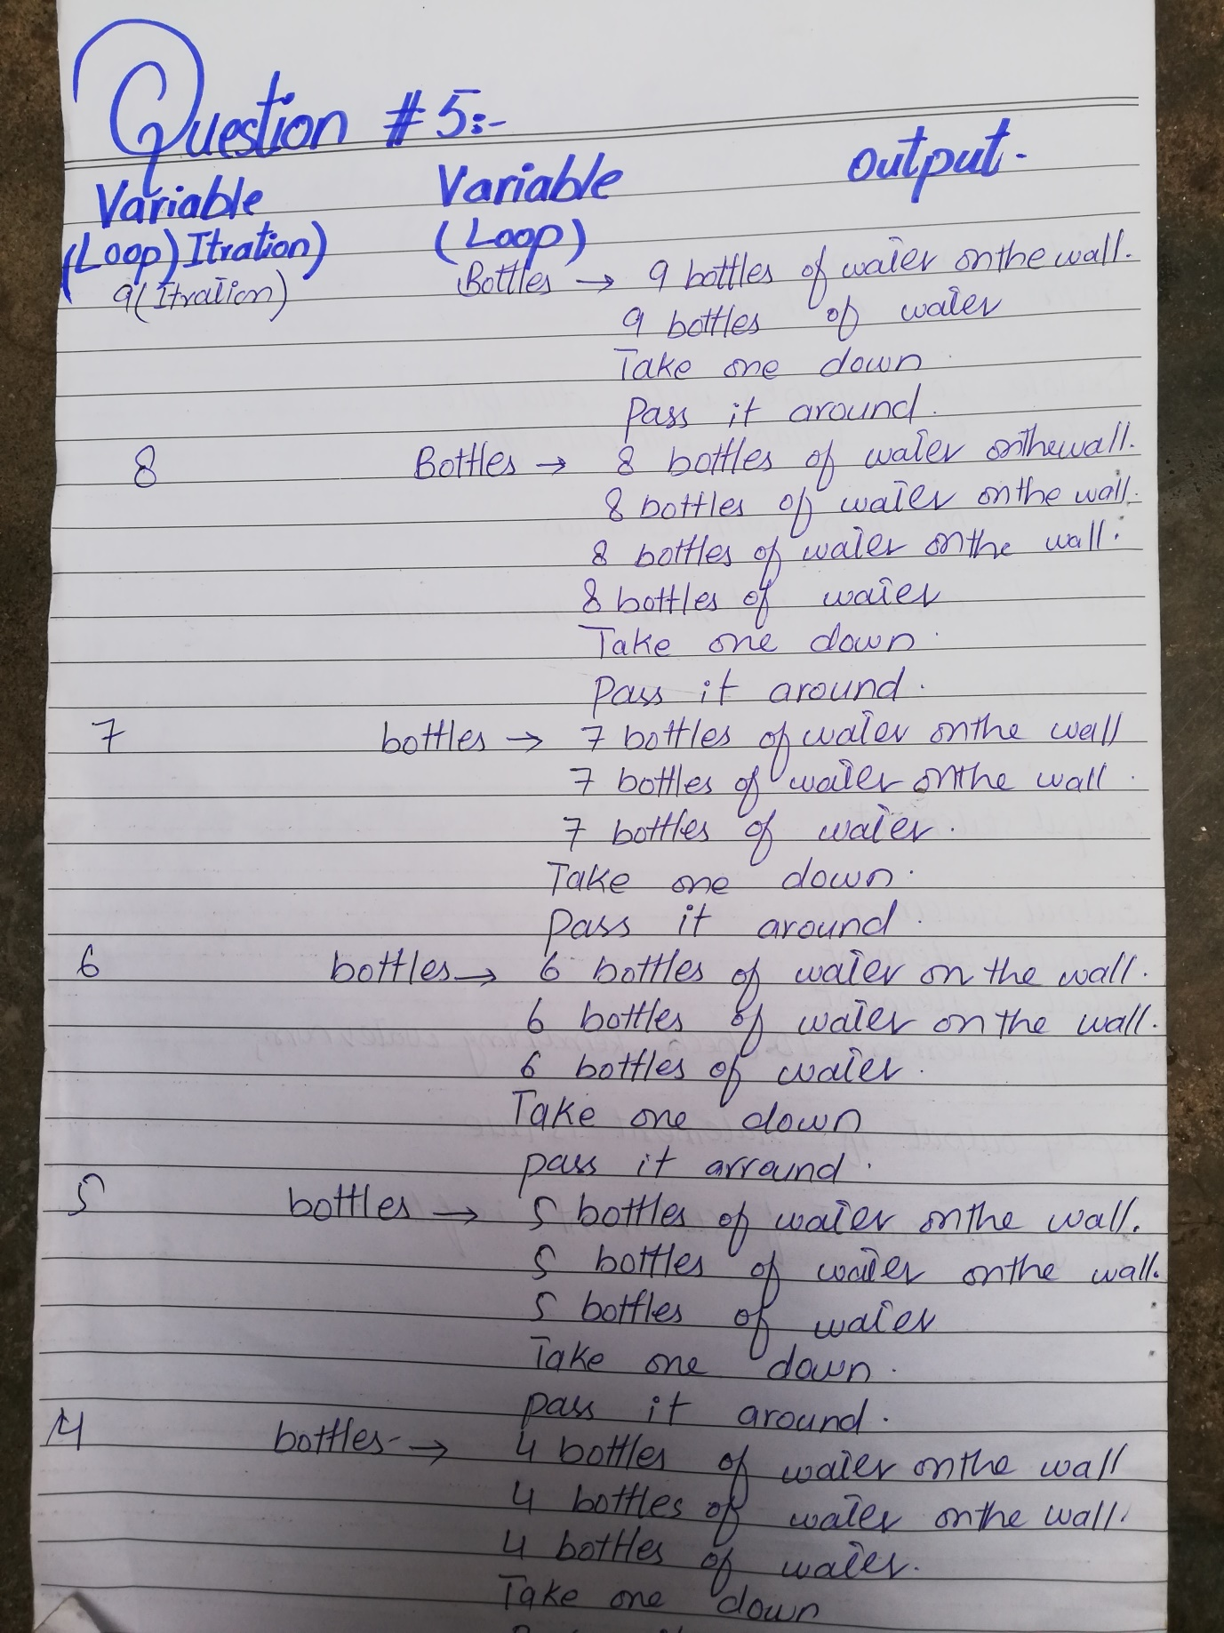

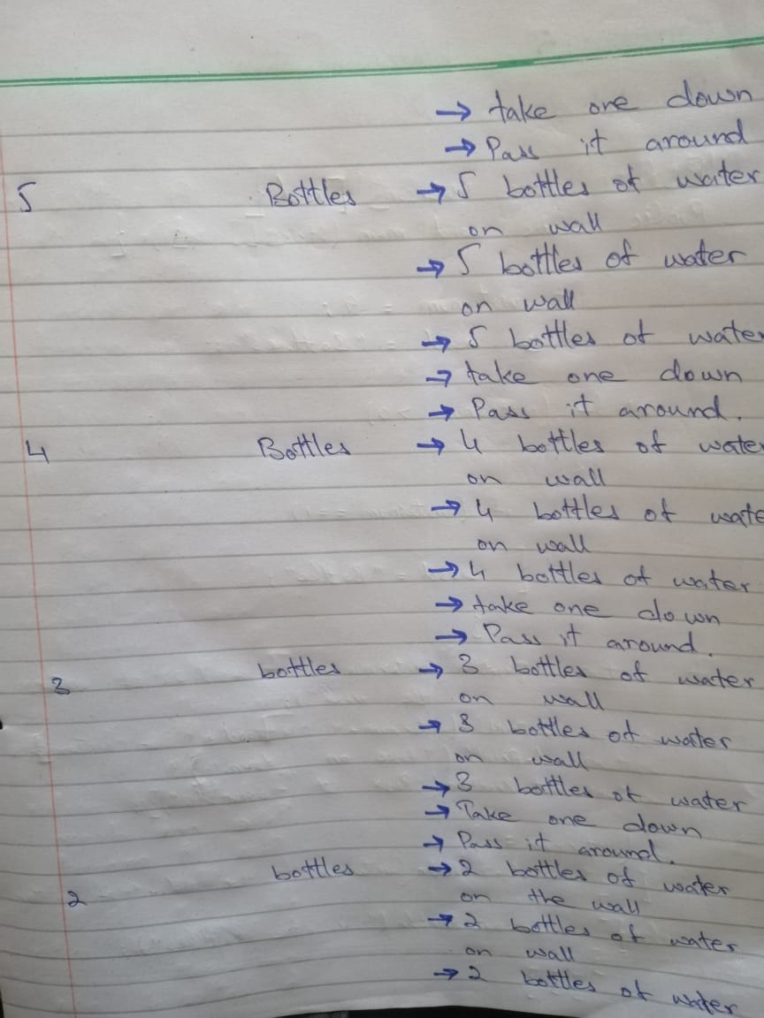

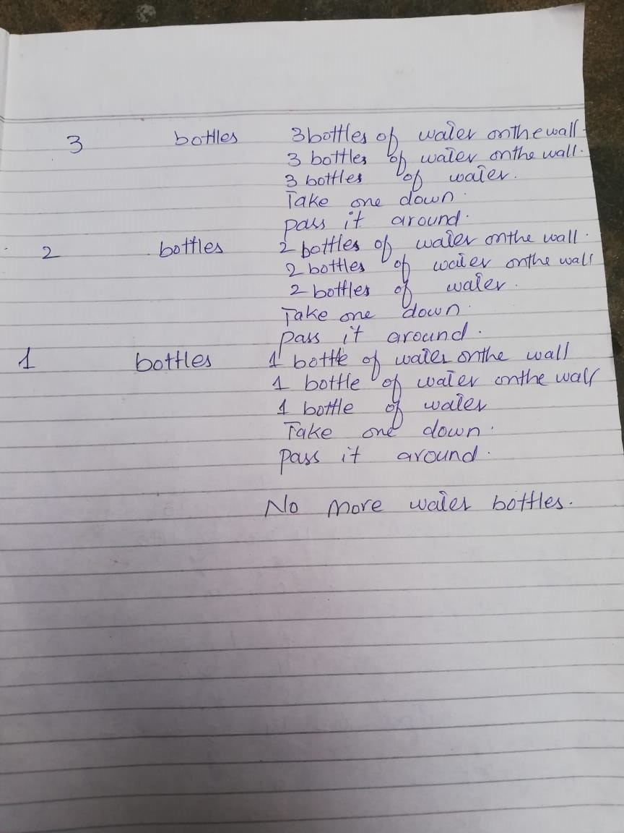

Q6. Run and c

ompile th

e code. Upload it on the GitHub.

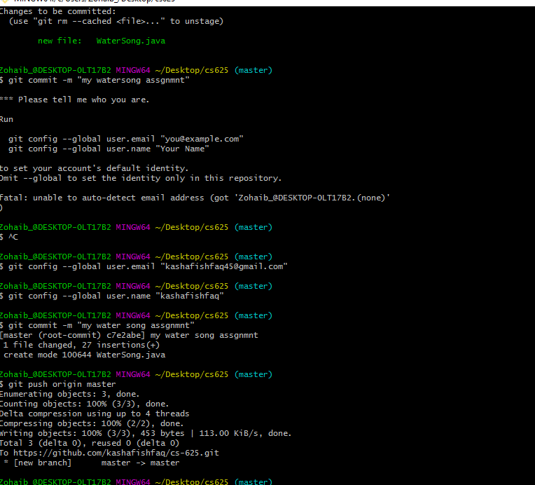

Q7. Program contains a logical error. Fix it with class name WaterSongFixed and write it

down on the notebook and paste the picture of it in the assignment file in shared Dropbox folder.

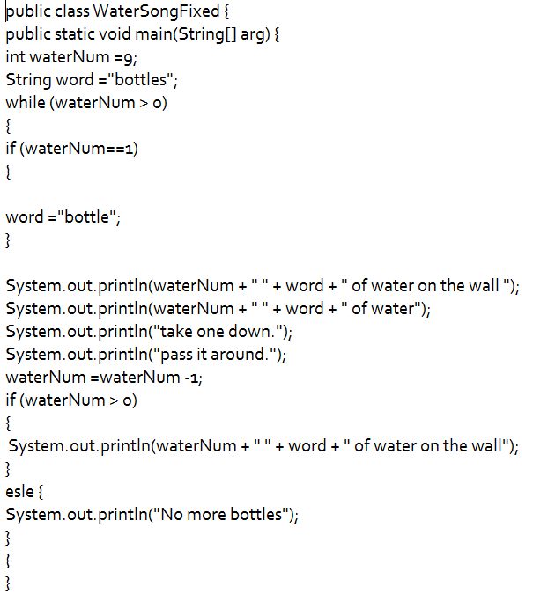

Q8. Upload WaterSongFixed

on the GitHub.

**public class WaterSongFixed {**

**public static void main(String[] arg) {**

**int waterNum =9;**

**String word ="bottles";**

**while (waterNum > 0)**

**{**

**if (waterNum==1)**

**{**

**word ="bottle";**

**}**

**System.out.println(waterNum + " " + word + " of water on the wall ");**

**System.out.println(waterNum + " " + word + " of water");**

**System.out.println("take one down.");**

**System.out.println("pass it around.");**

**waterNum =waterNum -1;**

**if (waterNum > 0)**

**{**

**System.out.println(waterNum + " " + word + " of water on the wall");**

**}**

**esle {**

**System.out.println("No more bottles");**

**}**

**}**

**}**

**}**

Q9. After completing all above questions, paste the screenshot of GitHub insights

showing

your weekly progress

in the assignment file of your shared Dropbox folder

